User Guide

This is Network Monitoring System appearance. Our GUI will be divided into four parts. First is the menu bar. Second is image icon button position. Third is left side. And finally, it is the right side.

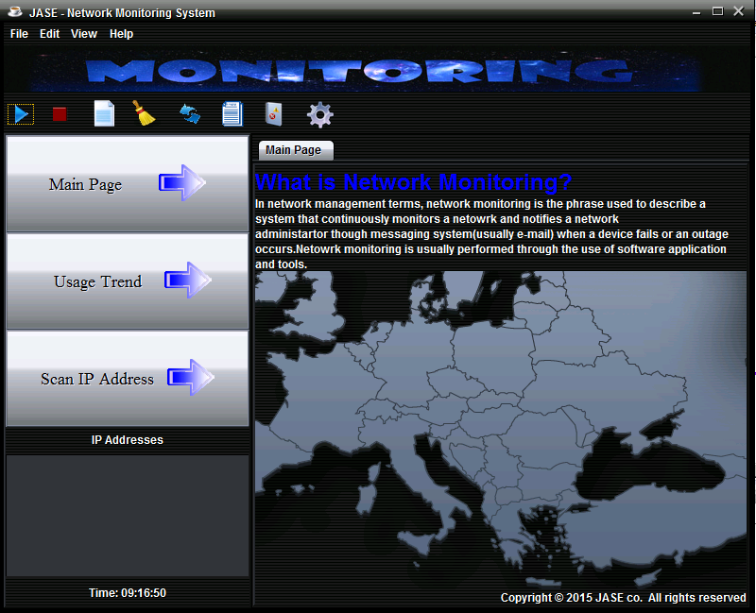

For the Menu Bar, we created four menu buttons. For example: File, Edit, View and Help. Also, when you click the menu button, you will see the some sub menu item in the menu.

**Menu – File**

It contains three menu items, they are New, History and Exit.

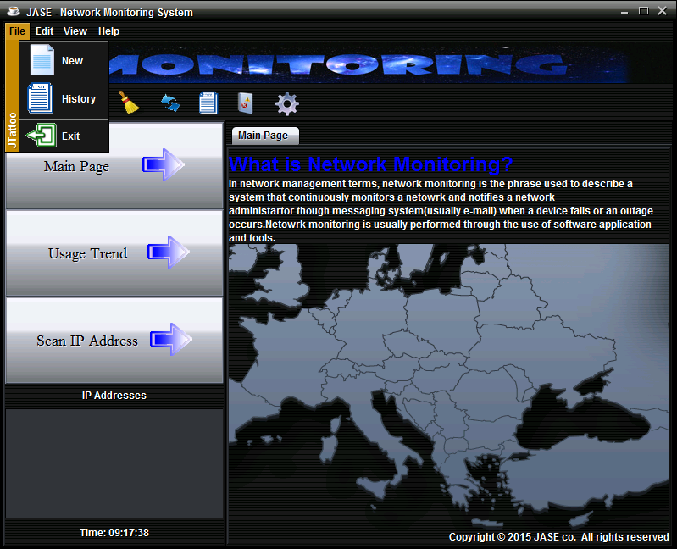

**Menu – Edit**

The “Edit” menu button include four menus item, Database Configuration, Database Auto Creation, Delete specific record and Clear.

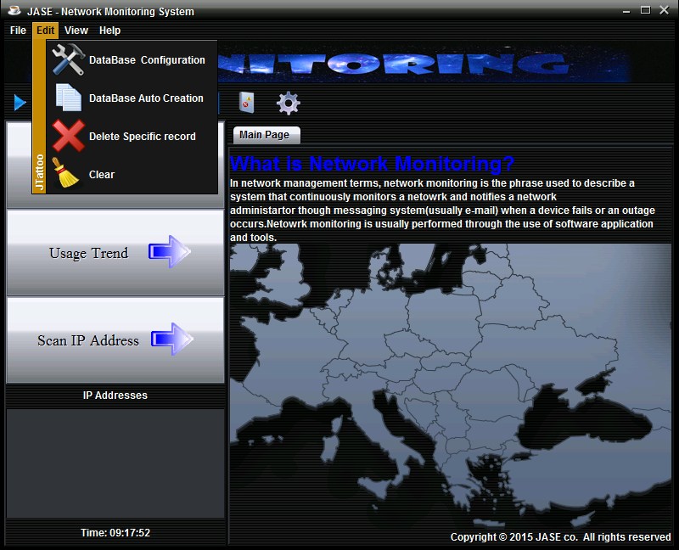

**Menu – View**

There are two item, “Start Auto Capture” and “Stop Auto Capture” for this menu.

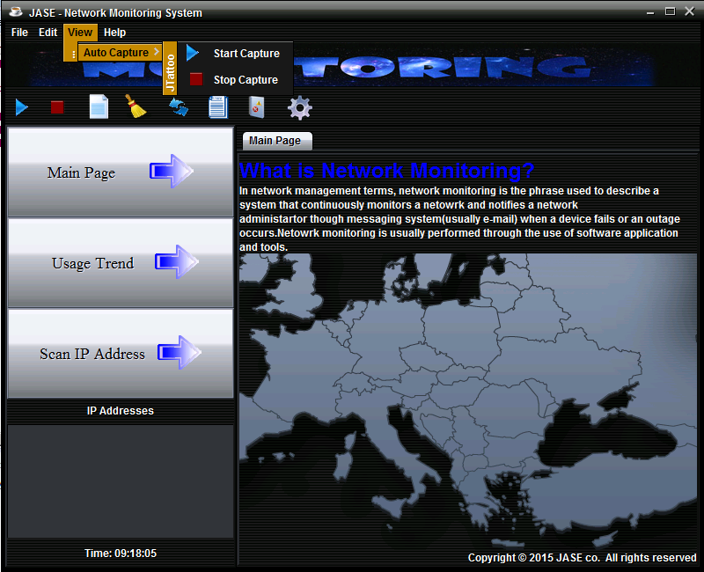

**Menu – Help**

Regarding the ”Help” menu, you will see two menu item, “About US” and “Web Page”.

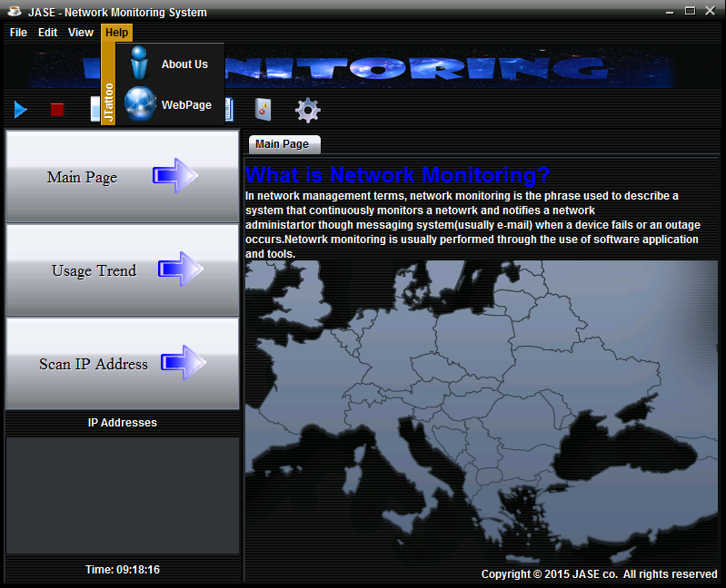

When you click the “about us” menu item, it will show the message dialog to provide contact information.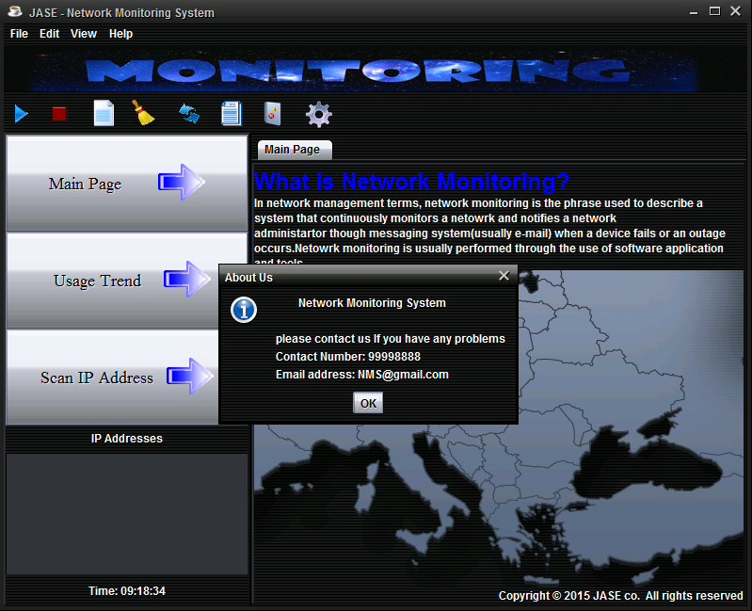

And then, we designed a web page, if you want to read extra information, you can click the “Webpage” button, After that, a web page will be showed with your default browser.

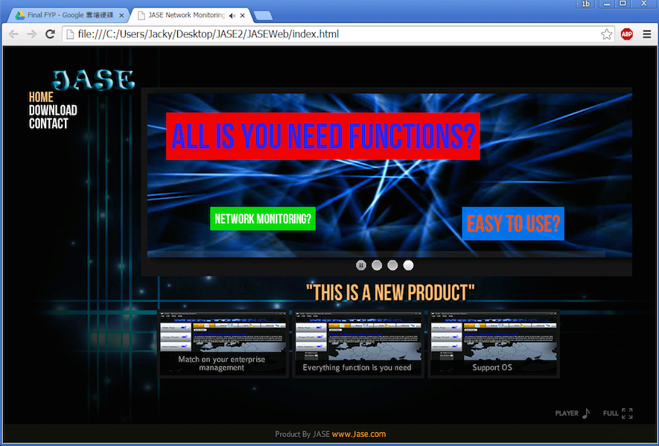

**Basic Configuration**

When you are using this system for the first time, you must finish the “Database Configuration”. The purpose is to create a connection between the system and database.

First, when you click “Database Configuration” button from the Edit menu, you will see the dialog that request for your username.

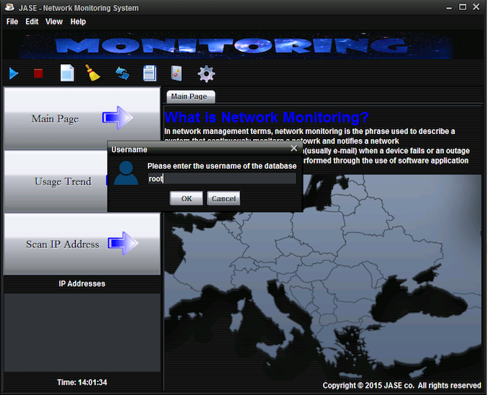

After you enter the username and click “OK” button, the next message dialog will show to you. This dialog will request for your MySQL password.

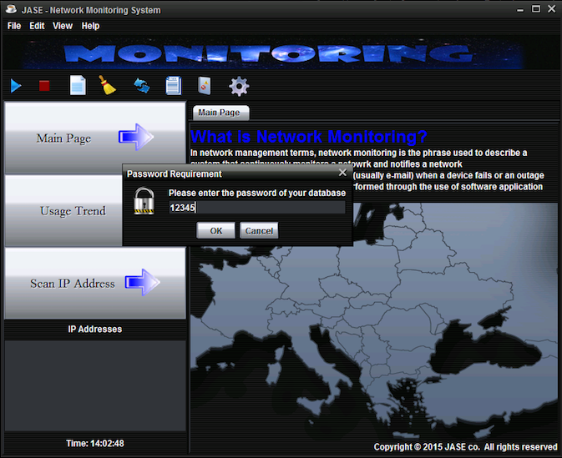

* Assume your password is 12345.

Next, you should enter your database’s URL, because it is the first time, you can just input the IP and leave the database name blank.

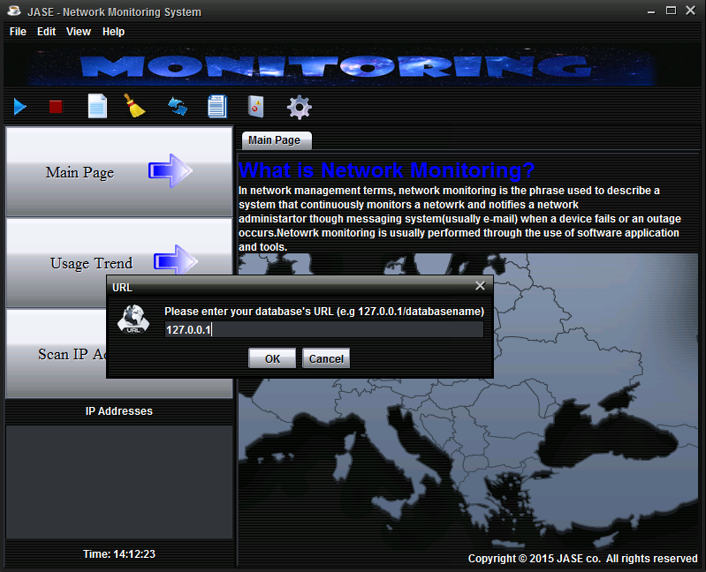

* Assume the database URL is 172.0.0.1

After you completed the above steps, the system will identify your input data, if data is correct, it will show a success message , otherwise it will show you error message.

Success to connect the database:

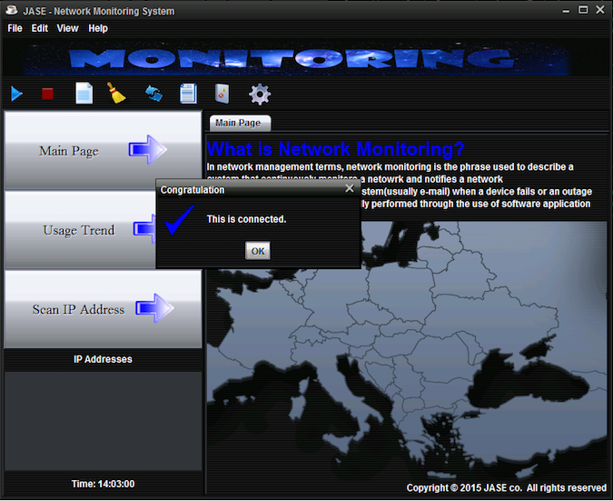

Not Success:

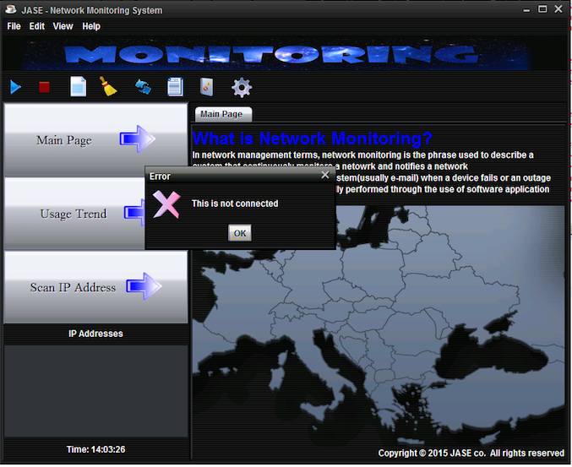

After you finished the Database Configuration and connect to the database successfully, you must also finish the “Database Auto Creation” button with the database name (any name you want) to create the database table.

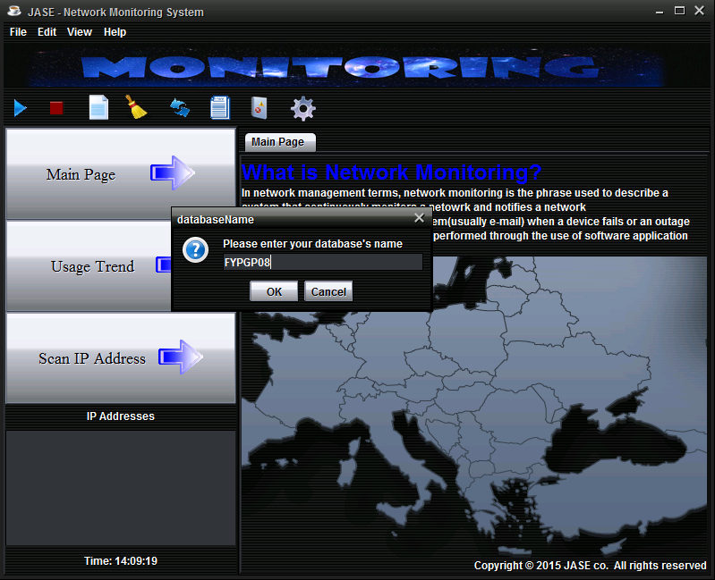

After that, when you click the “OK” button, it will show you success or error message dialog. If you received error message, you should try again.

Success to create the database table:

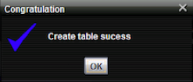

Fail to create database table:

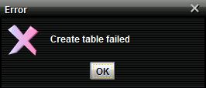

Finally, if you want to delete the database record, you need do the “Database Configuration” again. This time, you need to enter the database URL with the database name.

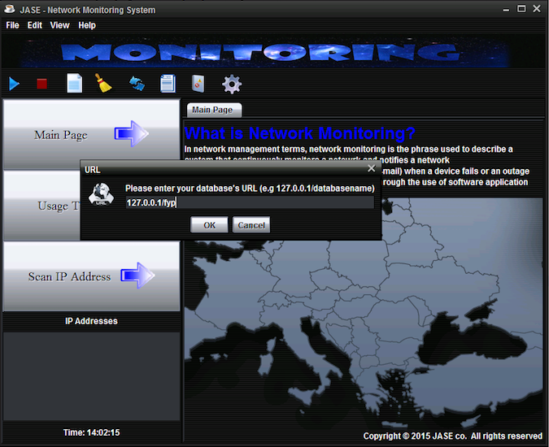

After the connection created, you can click the “Delete Specific record” button to delete specific database information.

When you clicked the “Delete Specific record” button, it will show you the IP which have records in the database. You can choose specific IP to delete all the record.

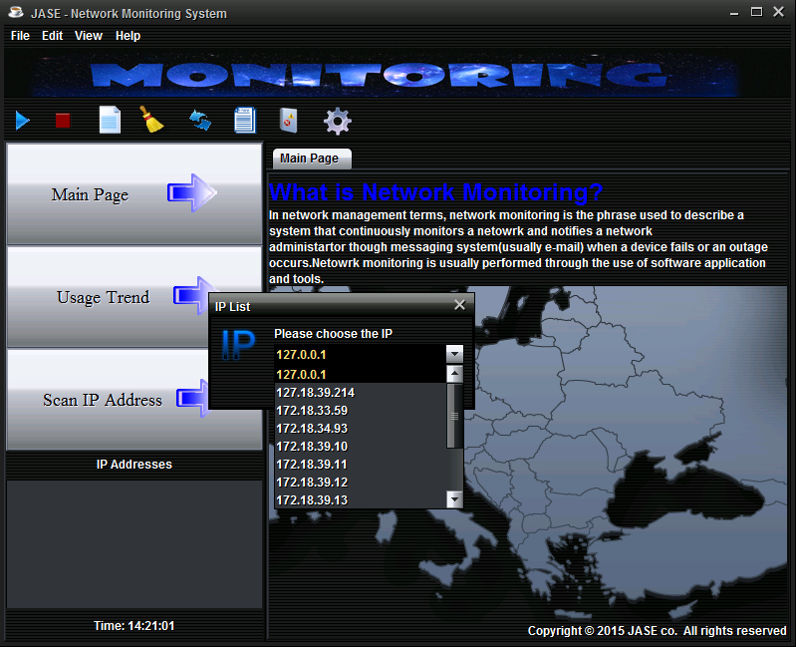

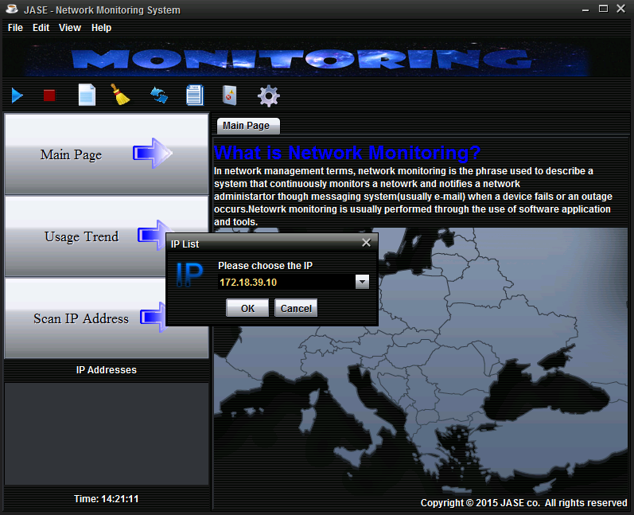

**Image Icon Button**

For the image icon button, the following page will introduce you about different button and functions. We created image icon button aim to provide a convenience way for using the function. Moreover, when you mouse move on the related image icon button, a text will pop out to let you understanding the function of the button.

**Image Icon Button – New**

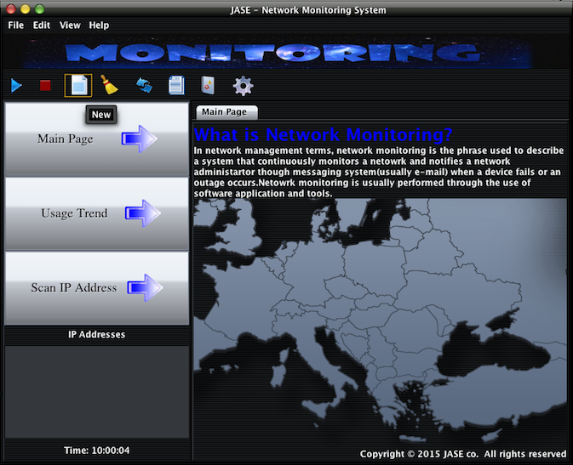

After you clicked the new button, it will show you two message input dialog for you to input the related information. First, you should enter the IP address of the target device. Second, you need to enter the community.

Assume you want to capture status from the device which IP address is 172.16.252.144, so you enter this IP address in the first message input dialog and click “OK” button.

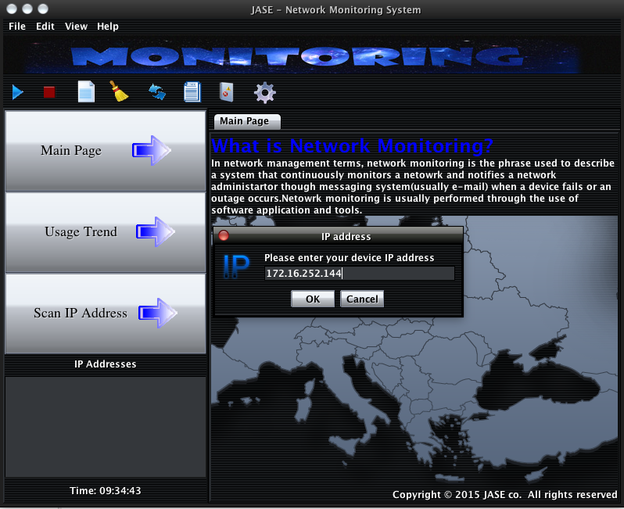

After that, you will see the next message input dialog which the community. 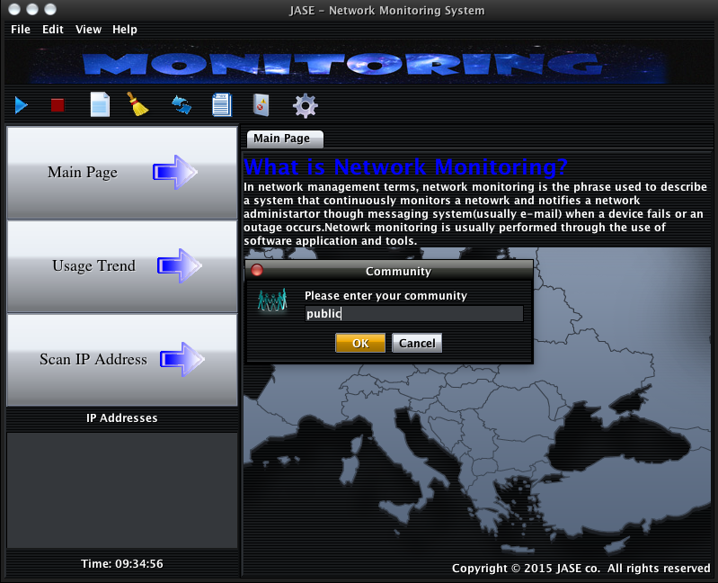

Enter your community here. I entered “public” for testing.

After that, you will see the next message input dialog which the CPU Limit value.

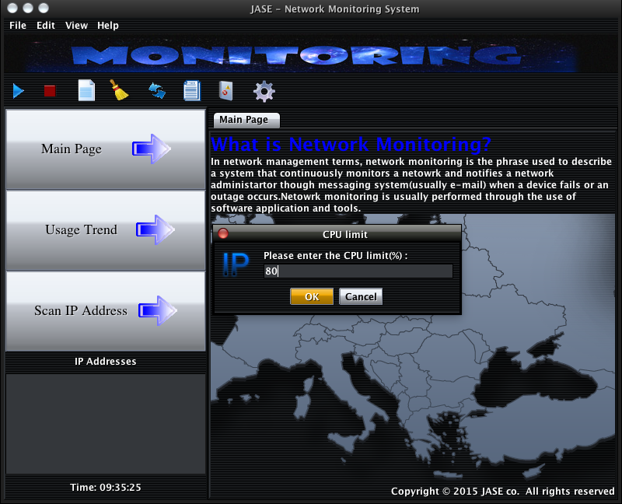

Assume we entered ” 80 “ for CPU limit value.

After that, you will also see the next message input dialog which the RAM Limit value.

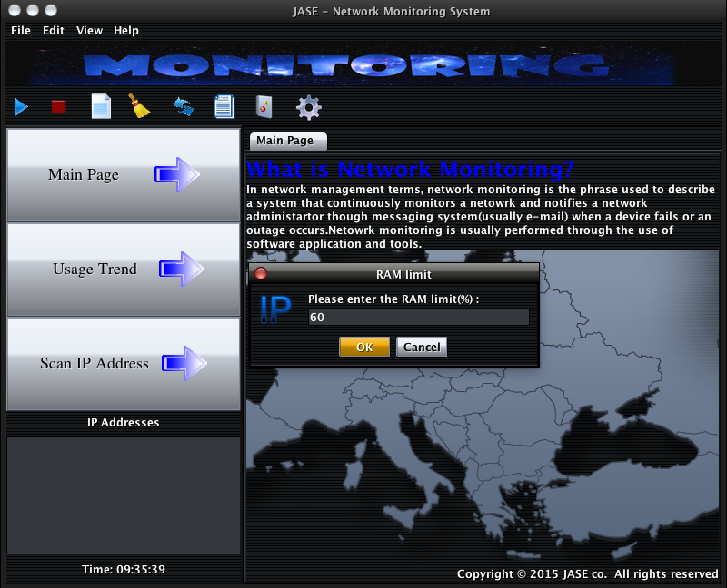

I entered “ 60” for the RAM limit value.

After you completed above two message input dialog, you will see the IP address (172.16.252.144) on the device list.

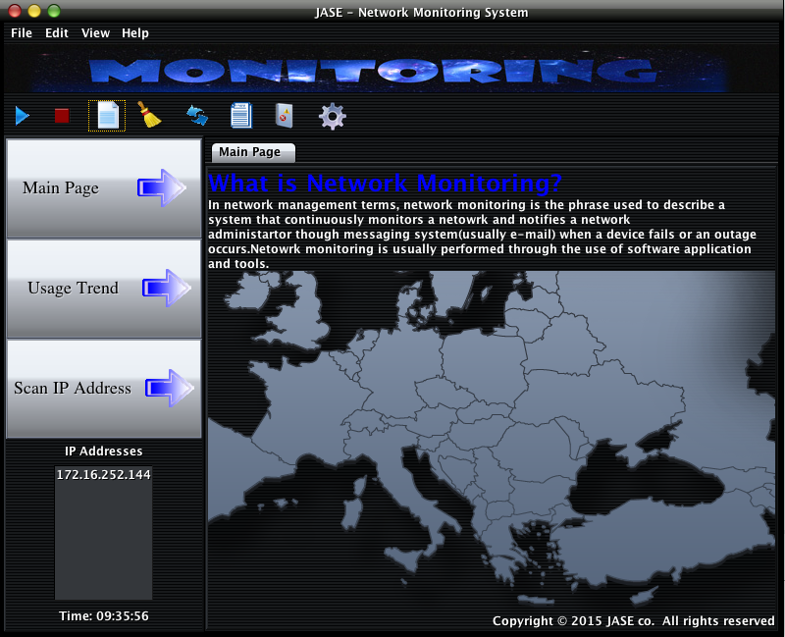

When you double click on the IP address (172.16.252.144).It will show your targets device status on the right side (It created a new tab panel). The status is including CPU usage, hard disk usage and up time, etc. In addition, we have made some pie chart such as Ram Usage pie chart. It can help you to understand the status easily.

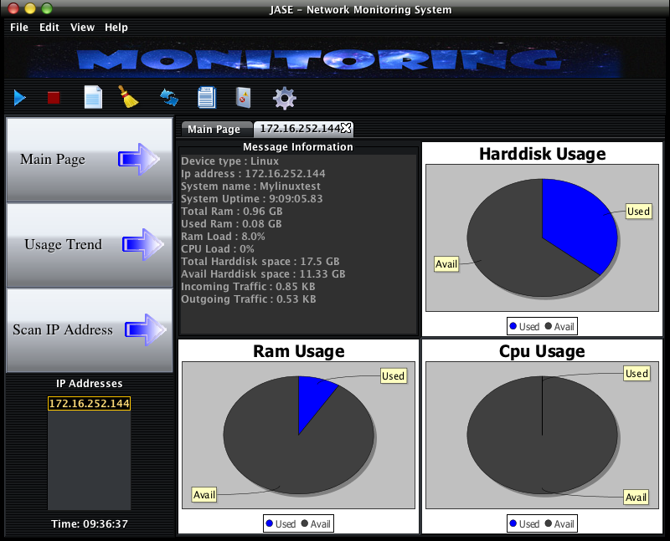

For the status information, It contains the following:

1. Device Type
2. IP address
3. System name
4. System Uptime
5. Total Ram
6. Used Ram
7. Ram Load
8. CPU Load
9. Total Hard Disk space
10. Avail Hard Disk space
11. Incoming Traffic
12. Outgoing Traffic

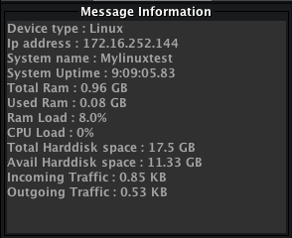

***Image Icon Button – Clear***

For the “Clear” button, it has two ways to clear current status on the GUI. First, you can use the (1) “Clear” button to clear. Second, you also can (2) cancel the tab to clear record. The following page will be show to their different effect.

(1) The clear button, you can click this button to clear all status include right panel and device list.

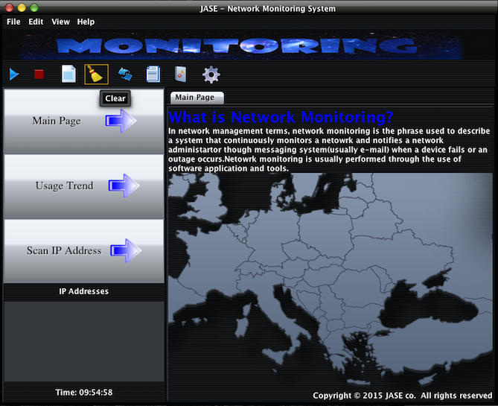

(2) Cancel the tab, there are some difference with the “Clear” button, because this function is not deleting all status. However, you can click the cross prompt icon on the tab panel to clear related status .

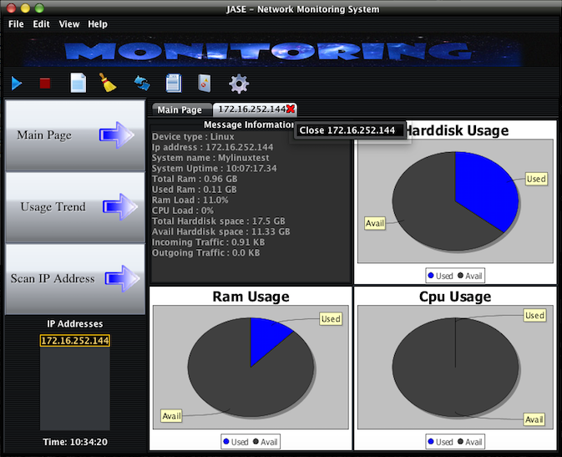

**Image Icon Button – Refresh**

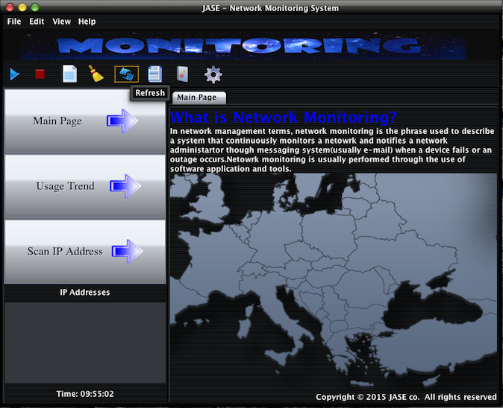

When you clicked the refresh button, the related status will be update. Also, our refresh button will auto detect which tab panel is shown now, so it can identify to refresh it.

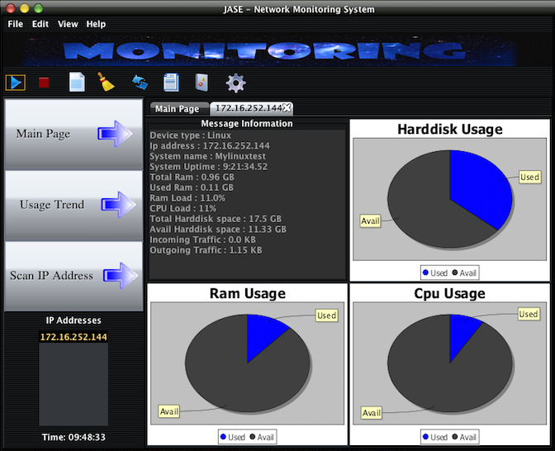

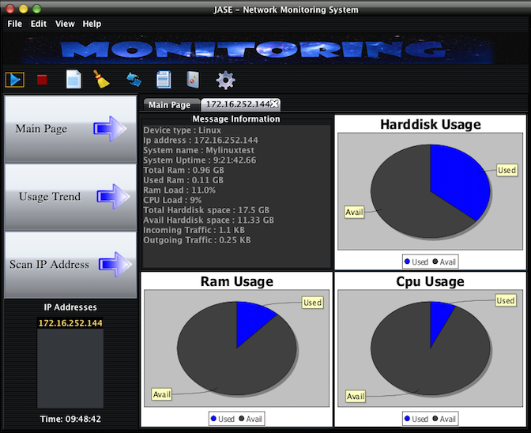

When you click the refresh button, the status will be changed.

**Image Icon Button – Start / Stop Auto Capture**

For the start / stop auto capture, you can click the start auto capture button to allow system auto to capture status and updated it. The auto capture function will capture status every 5 second. Therefore, if you want to stop auto capture, you can click the stop auto capture button, the auto capture will be suspended.

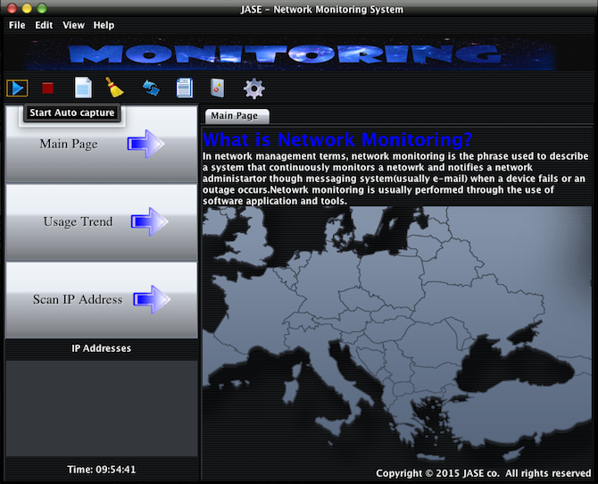

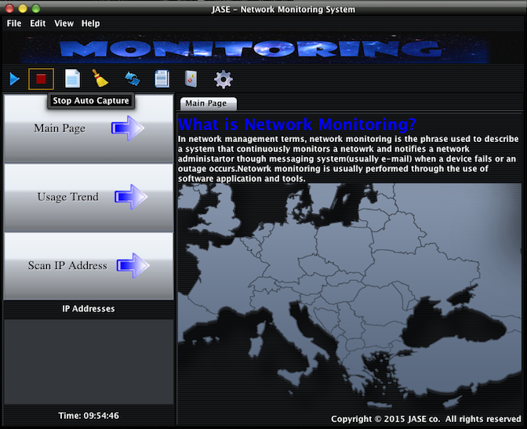

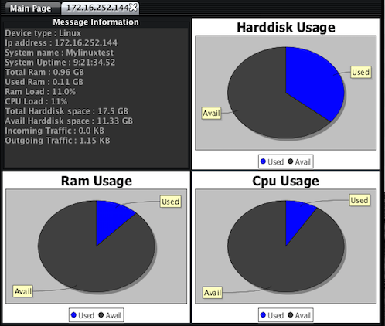

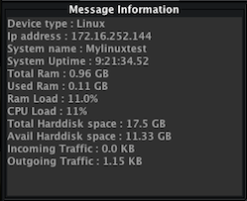

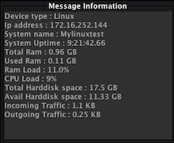

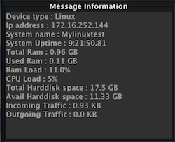

**Image Icon Button – History**

This function used to get all status record from target device.

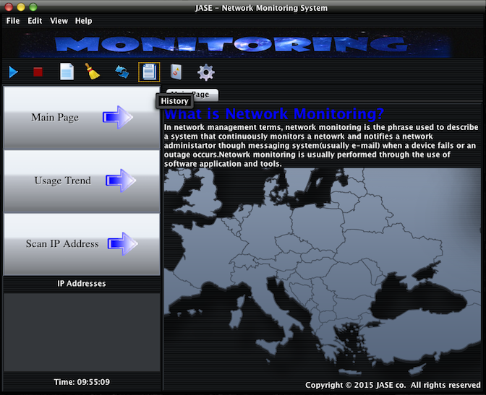

When you click the “History” button, there are two messages dialog need to be selected they are format and IP address. Firstly, the first message dialog will request end-user to choose the report format. Our report function provide two formats, “.txt ” and “ .xlsx “. (.txt is notepad standard format, and .xlsx is Microsoft Excel standard format)

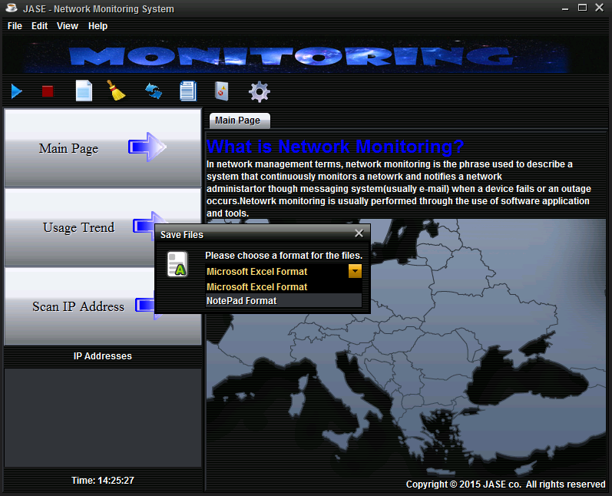

After that, when you selected the format and click the “ok” button, it will show you the next message dialog. The dialog will show you the IP address which is valid in a list and you can choose the target device.

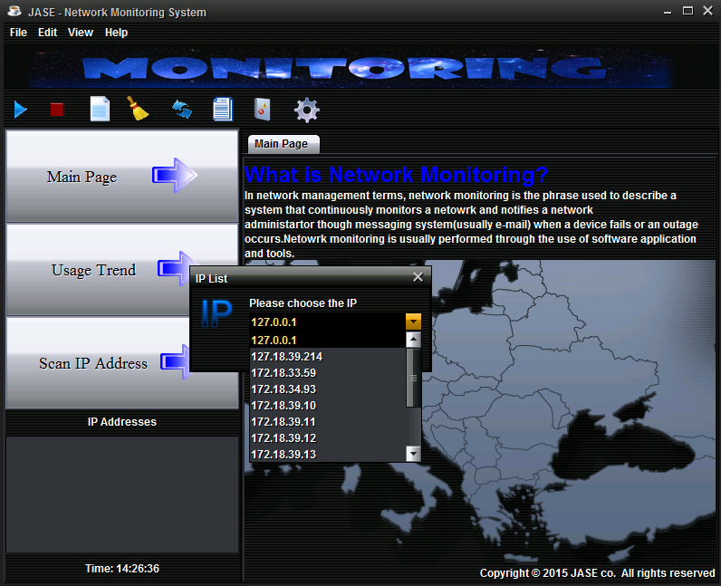

After you choose the target device, a text or excel file will generate to the directory of this system.

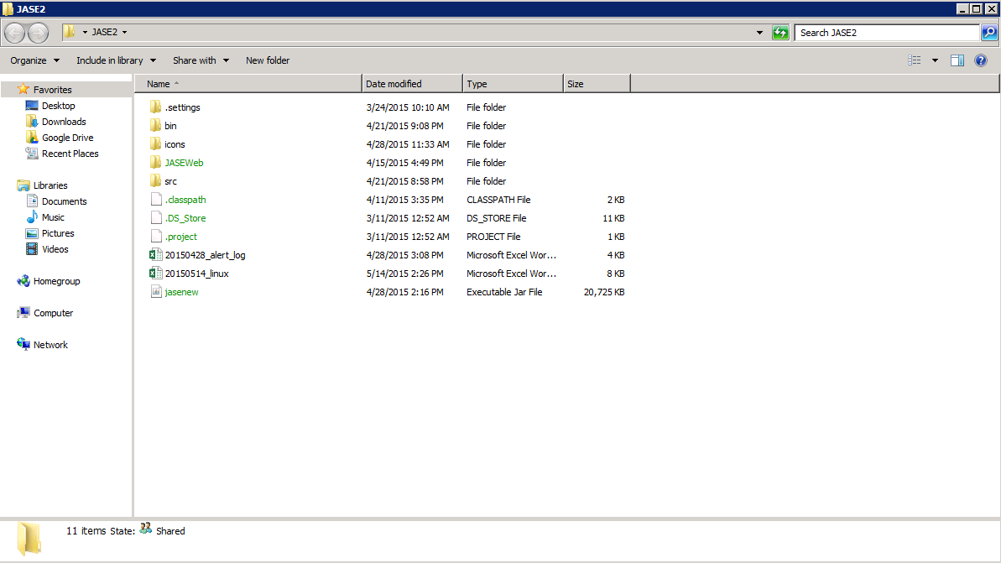

**Image Icon Button – Logging records**

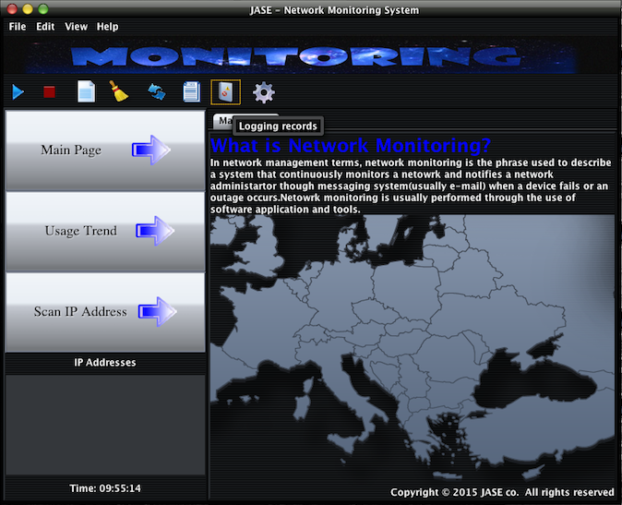

When you click the “Logging records” button, there are two messages dialog need to be selected they are criteria for the file and IP address. Firstly, the first message dialog will request end-user to choose the criteria for the file. Our “Logging records” function provides two criteria such as IP and ALL.

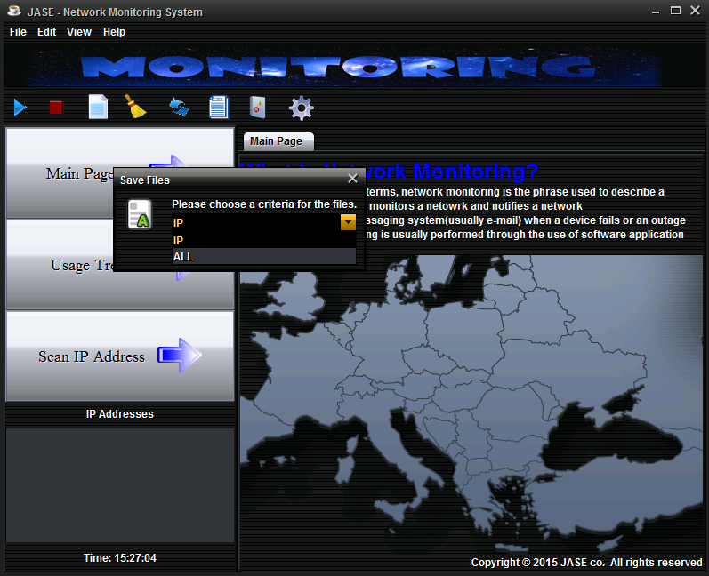

* Assume we selected ” IP “ criteria for the file.

After that, when you selected the criteria and click the “ok” button, it will show you the next message dialog. The dialog will show you the IP address which is valid in a list and you can choose the target device.

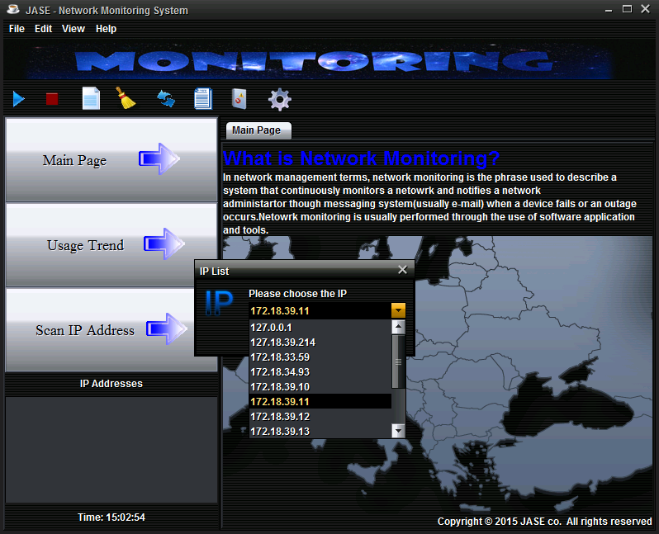

* Assume we selected the IP address is 172.18.39.11

After that, you will see the output in your folder.

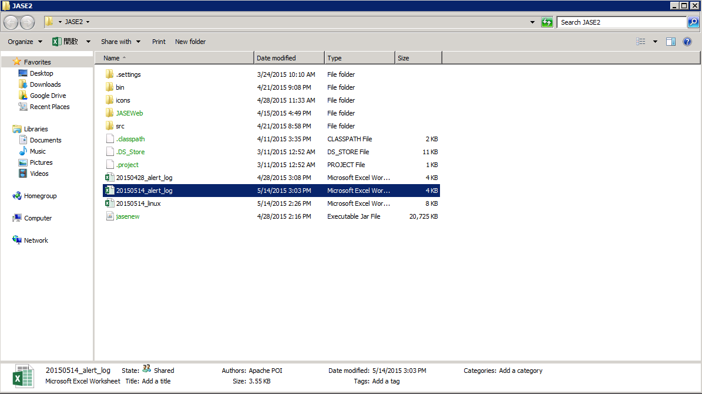

**Image Icon Button – Alert setting**

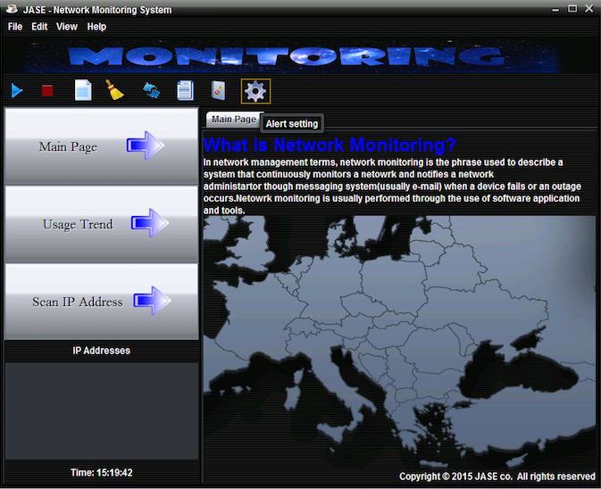

* Assume you added a device and started capturing status from it. Click the “Alert setting”. Then, you will see another new frame. For the new frame, it has two messages, for example, “CPU Limit Value” and “RAM Limit Value”. (Please note that you need created at lease one device otherwise you cannot open the “Alert setting” button.)

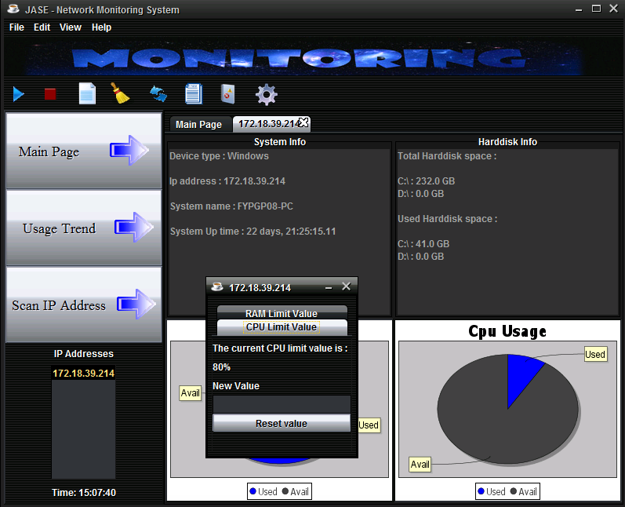

RAM Limit value setting is 60% because when you create a device, you need to enter the initial value for the RAM limit value.

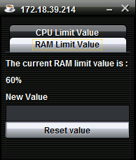

CPU Limit value setting is 80% because when you create a device, you need to enter the initial value of the CPU limit value.

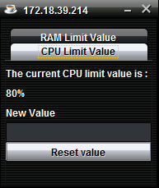

* Assume you want to set the CPU limit value is 0.

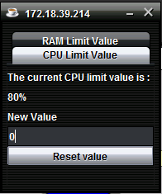

After that, when you click the “start auto capture” button, you will see message dialog, because you set the CPU limit value to 0, so the system will show alert to remind you the related device CPU is over the 0 (CPU limit Value)

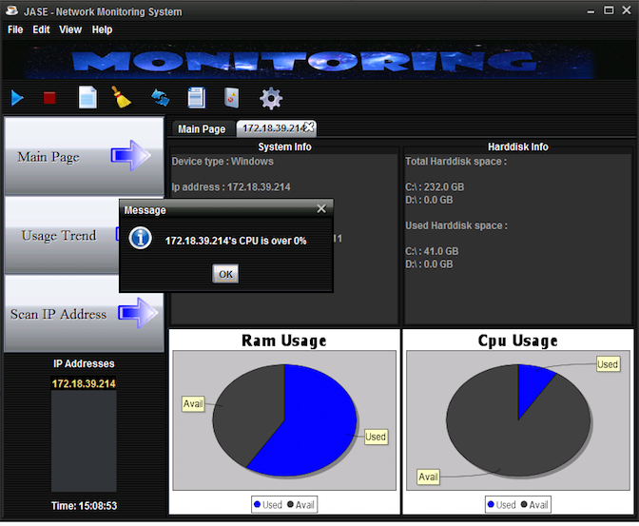

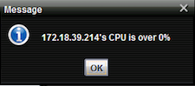

Moreover, the RAM Limit value function is same with the CPU limit value function.

For example: now, end-user want to set the RAM limit value is 0.

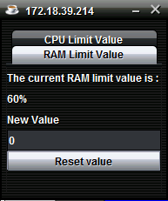

After that, the alert will show it to remind you the RAM over 0.

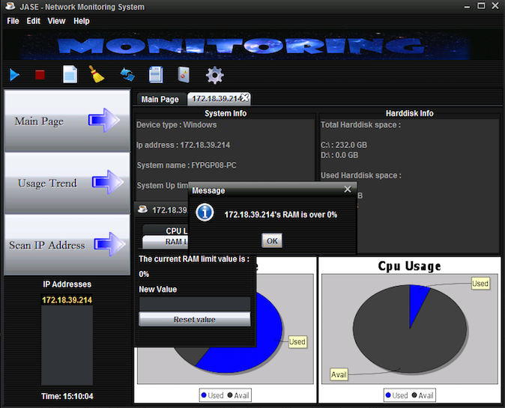

For the left side, the following page will introduce to you three button such as main page, usage trend and scan IP address. Also, there also have device list.

**Left Side – Main Page button**

Main page button use to show the main page on the right side.



If you click the main page button, the right side page will be changed, such as following:

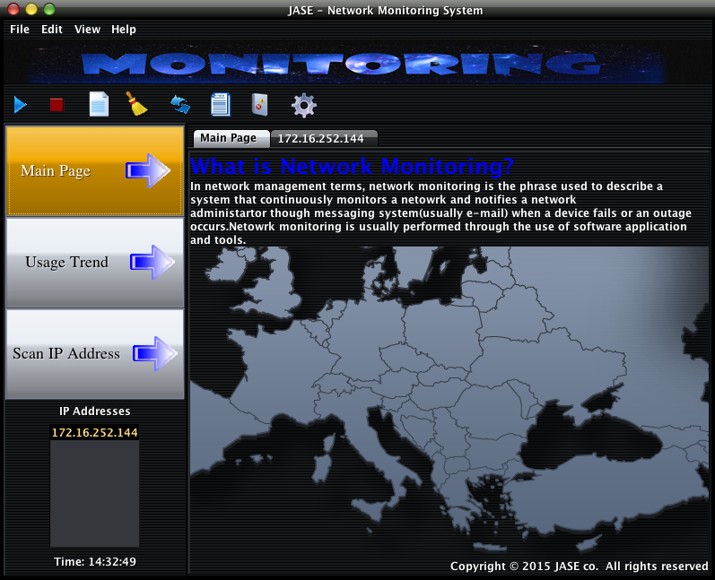

**Left Side – Usage Trend Button**

For the “Usage Trend” button, you can click the usage trend button to make a line chart. When you clicked the usage trend button, it will show the message dialog with IP List, this function is to choose the exist IP address form the database.

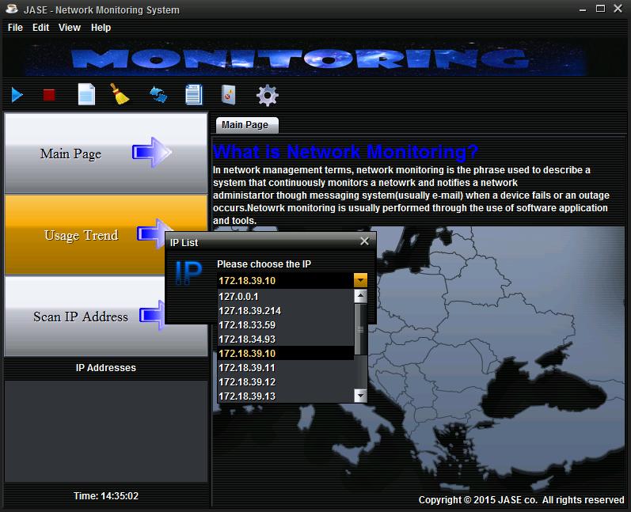

After you selected a target IP address, then you will see the next dialog, which provide you a interface to choose the type of data that you want to get. For Example, the CPU Load.

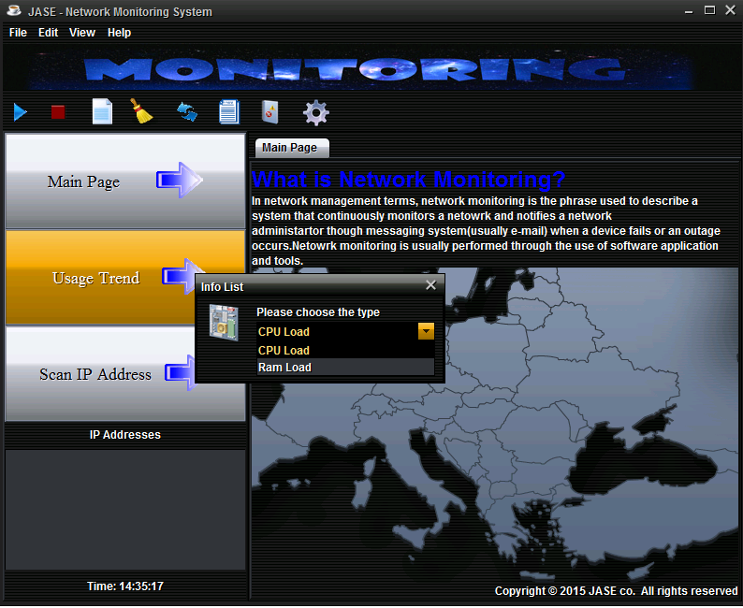

* Assume you choose the CPU Load type.

Next, you should input the day. For example, if you input 2015-04-28, it will show the record from 2015-04-22 to 2015-04-28.

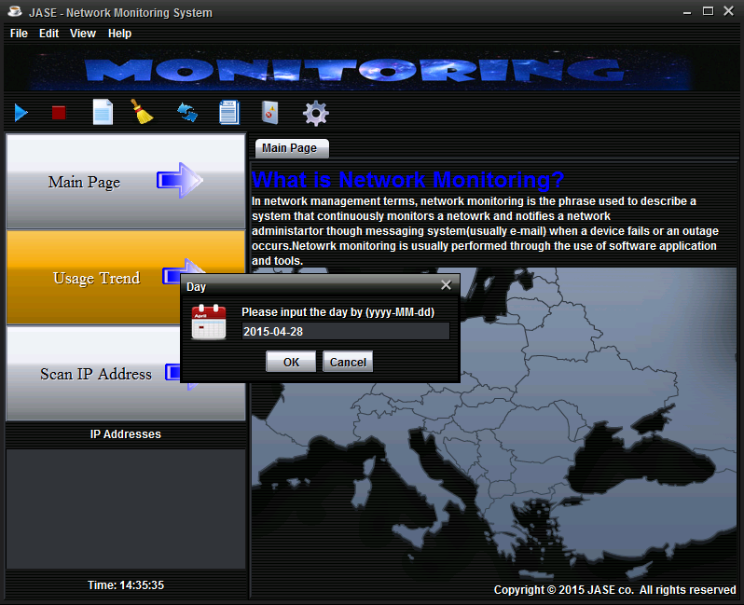

Finally, when you completed above parts, the usage trend chart will be show it such as following:

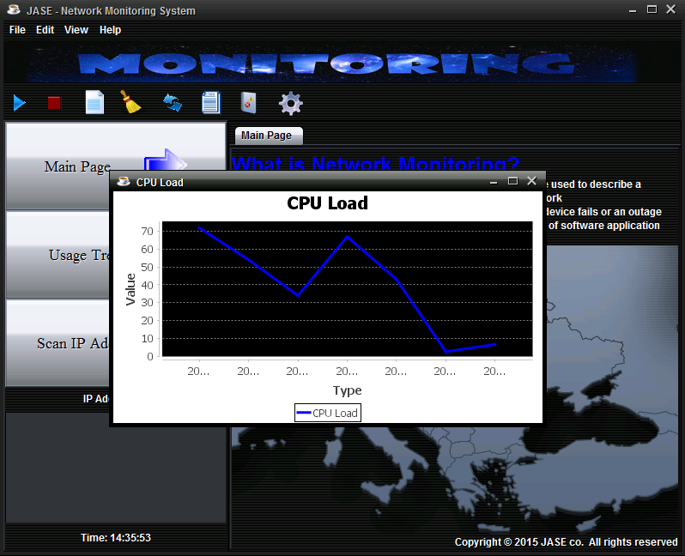

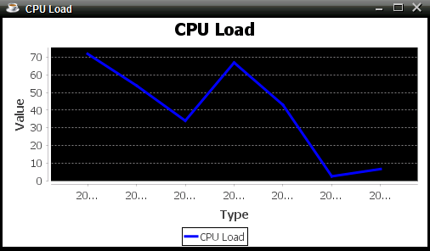

**Left Side – Scan IP address Button**

Scan IP address function provide network scanning so that it will show the valid IP address of the input network. So that, when you click the scan IP address button, you should input the range IP address to textbox from the message dialog. For example, if you input 172.18.39.255/24, it will scan from 172.18.16.1 to 172.18.39.255. If you input 172.18.39.130/24. It will scan from 172.18.39.1 to 172.18.39.130.

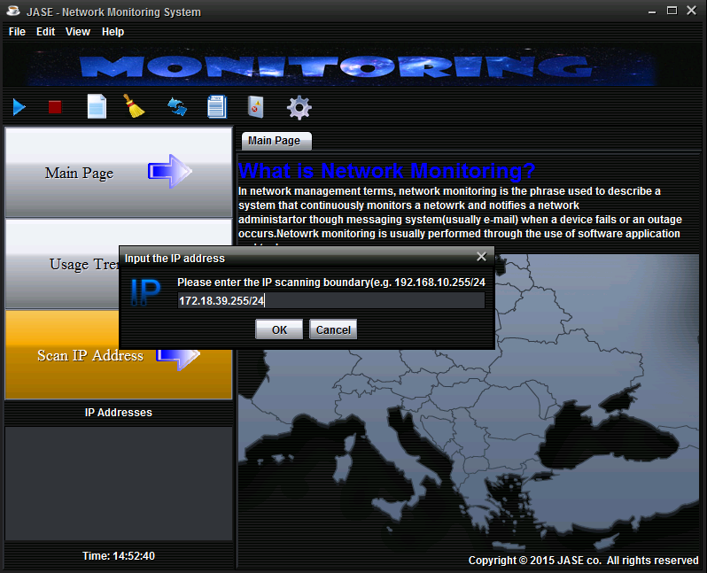

* Assume you input the range IP address is: 172.18.39.255/24

After, when you click “OK” button, you should input community in the textbox of the new message dialog.

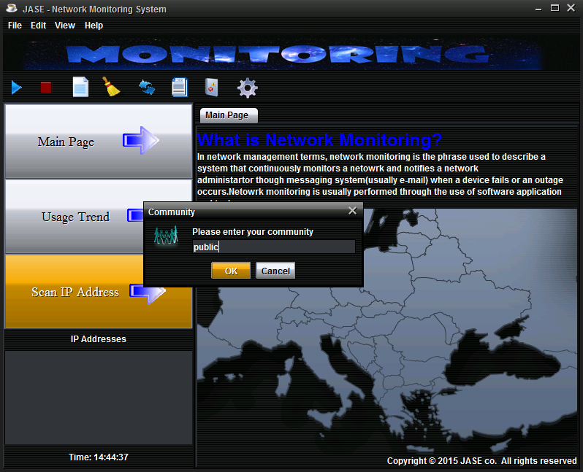

* Assume your community is public.

Finally, you can see the valid IP address in the device list.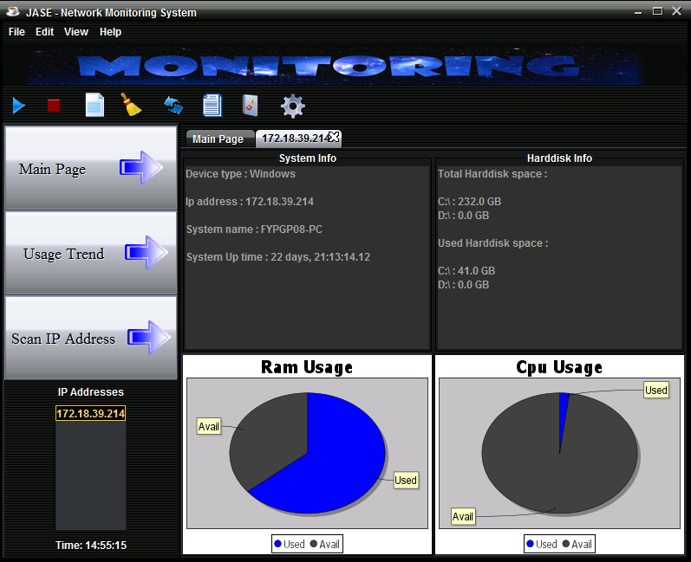

__End